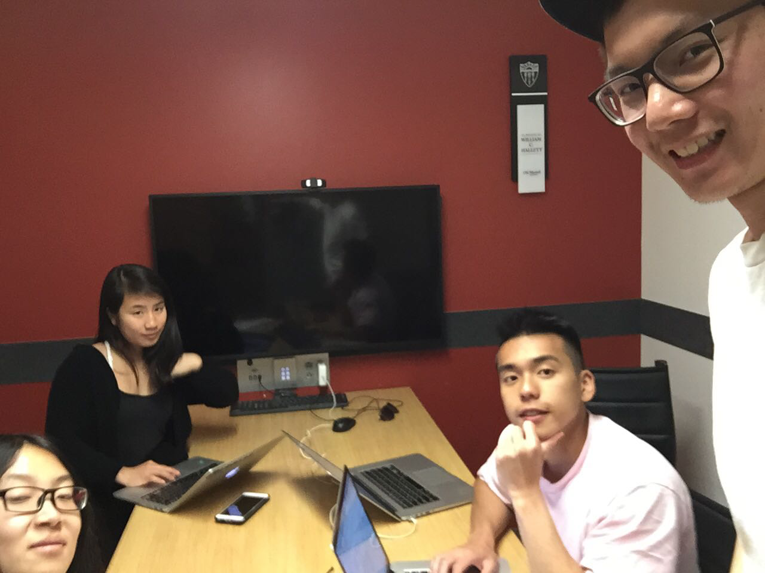

Allocated meeting time: April 24rd, 5:00pm-6:00pm

Actual meeting time: April 24rd, 5:00pm-6:00pm

Product owner: Professor Halfond, TAs, CPs

Scrum master: Gong Chen

Team members: Lingyi Li, Joann Lin, Peixuan Liu, Ryan To, Tuling Zhao

Scrum summary:

We were fixing bugs in our text cases together.

1. What have you accomplished since the last meeting?
2. Are there any obstacles in the way of meeting your goal?
3. What will you accomplish before the next meeting?

Gong Chen:

1. Fixing the black & white filter.
2. None.
3. Working on document.

Lingyi Li:

1. I was creating the burndown charts.
2. None.
3. I will finish the burndown charts and write other sections in the document

Absence Reason: I have a class at this time

Joann Lin:

1. Modified styling to make website responsive
2. None
3. Will assist with producing documentation

Peixuan Liu:

1. Added some test cases to SaveCollageServletTest
2. None
3. Add more test cases to SaveCollageServletTest

Absence Reason: Have to finish homework for another class

Ryan To:

1. I have finished the blackbox test case for download
2. none
3. I will write test case for https functionality

Tuling Zhao:

1. Worked on documentation
2. none
3. Will work on documentation